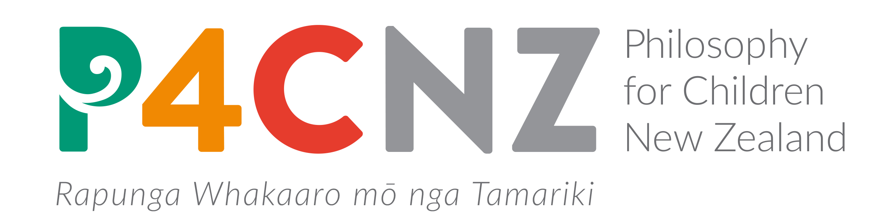

10 reasons to introduce philosophical inquiry into your classroom, using the
“Philosophy for Children / Community of Inquiry” approach:

- P4C encourages creative and critical exploration of the “big questions” about truth, goodness, friendship, possibility, knowledge, belief, justice, identity, beauty, mind, meaning, responsibility, reason, freedom, reality, language, rights….

- Inquiry is collaborative and student directed. It develops student agency, self-responsibility, reflectiveness, and a wide range of thinking and meta-cognitive skills.

- Continuing international research shows P4C results in significant gains in so many areas that are identified as needed by New Zealand children:

- Critical reasoning
- Reading
- Mathematics
- Concentration
- Collaboration
- Self esteem
- Participation
- Persistence
- Reduction in bullying
- Communication and interpersonal relationships

Impact on literacy and Numeracy: The large-scale U.K. Education Endowment Foundation Study (2015) showed that students doing philosophy once a week made approximately two additional months’ progress in reading and mathematics. The biggest positive impact was on disadvantaged students (3 months progress in maths, 4 months progress in reading)

- P4C works for students of all abilities, and produces the greatest benefits for low and middle ability students.

- P4C is conducted in a primarily oral and collaborative “community of inquiry”, which makes it attractive to many students, including Māori and Pasifika students.

- Australian evidence shows that students who do P4C perform very well indeed in Australian national standards testing, without “teaching to the standards”.

- P4C develops all of the Key Competencies set out in the New Zealand Curriculum.

- Students transfer skills learned in the community of inquiry to other parts of the curriculum

- Participation in philosophical communities of inquiry develops respect, tolerance, open mindedness, and both rigour in inquiry and care for others – a perfect recipe for citizenship.

- Students, from Year 1 to Year 13, love it, are disappointed if they miss a session, and report significant benefits for later academic success! (see website www.p4c.org.nz/about)

